Lab-05
Write Python code to implement the following. Consider dataset files as “iris.csv” and “drug.csv”
1.
Build a DecisionTree classifier to classify IRIS flower dataset
Use 80% of data for training and 20% for testing.
Display accuracy score and confusion matrix of the trained model on test data.
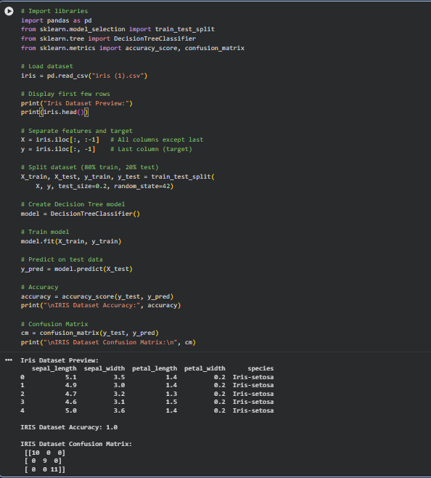

2. Build a DecisionTree classifier to classify Drugdataset
Use 80% of data for training and 20% for testing.
Display accuracy score and confusion matrix of the trained model on test data.

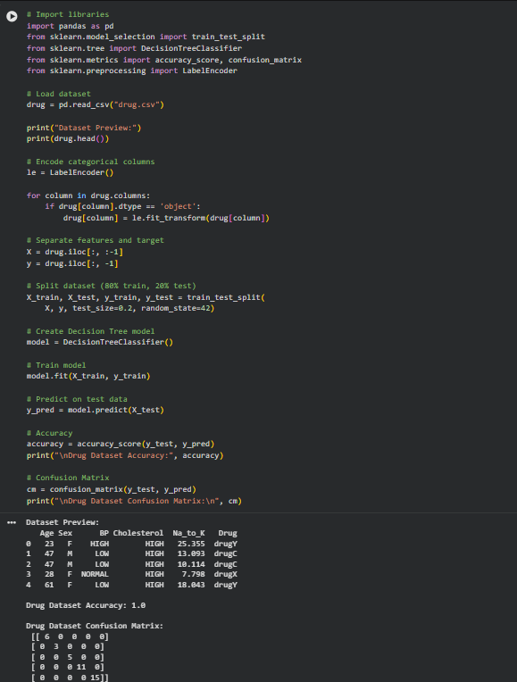

Write Python code to implement the following. Consider dataset file “petrol_consumption.csv”
Build a RegressionTree to predict petrol consumption
Use 80% of data for training and 20% for testing.
Display “Mean Absolute Error, Mean Squared Error, Root Mean Squared Error” for test data.
